# 2019 DDJ-1000 v6.5.0 - BOME mapping for Traktor Pro 3 and 2 with jog Screens - DJ Estrela

**HOW TO DOWNLOAD:** you can ONLY download the mapping if you register and verify your email in the DJTT site!

Main Links:

* Download Link: [https://maps.djtechtools.com/mappings/9279](https://maps.djtechtools.com/mappings/9278)
* Images: <https://www.facebook.com/pedro.vale.estrela/media_set?set=a.2244380098947850>
* Technical discussion: <http://forum.djtechtools.com/showthread.php?t=96024>
* Demo (updates): <https://youtu.be/h9tQZEHr8hk>
* Demo (base): <https://youtu.be/>[EkSJ9Ug9Zuk](https://www.youtube.com/watch?v=EkSJ9Ug9Zuk)

Summary (Jog screens BOME mapping):

* This is the first mapping for the DDJ-1000 for TP3/TP2 supporting Jog Screens. This requires BOME Pro MIDI translator. It works on both Traktor 3 and 2. Free trial versions are available to test everything.
* This mapping is more complex than previous ones. Be sure to read the FAQ below. Folder “installation help” has a PDF on the installation and correct startup steps for BOME.
* If you have ANY problem please report it in the comments section. Don't disrespect the ridiculous time that people spend to make complex mappings by just pressing a thumb down without leaving any steps to reproduce the issue. Thank you.
* All my mappings are - and always will be - a free gift to the community. Some years ago, DJs could use any Software with any Hardware; this mapping makes a small contribution for this model. If you want to show further appreciation, PayPal donations are welcome ([pedro.estrela@gmail.com](mailto:pedro.estrela@gmail.com))

v6.5.0 DEMO Jog Screens using BOME:

* 0:35 Needle position, BPM, Tempo percentage, Time elapsed/Remain, Key Variation
* 1:45 Loop/Beatjump sizes are displayed on the main display
* 2:25 Shift layers shows Base BPM, Tempo range, Loop sizes and Beatjump Sizes
* 4:00 Scratching quality was improved; shift+vinyl disables scratching
* 4:47 shift+quantize resets the jog screens
* 6:04 Quick demo of the previous features: JogFX, Rolls, PadFx, MixerFX, MacroFx
* 8:08 Pioneer BeatFX are in MST channel; TK effects are in channel 1..4

FAQ JOG SCREENS:

* **Q#1: What is the minimum setup to try this mapping FOR FREE?**A#1: Please download the trial versions of both a) Traktor Pro 3.2 ([download](https://www.native-instruments.com/en/products/traktor/dj-software/traktor-pro-3/demo-and-downloads/)) and b) BOME Pro 1.8.3 ([download](https://www.bome.com/products/miditranslator#downloads)). Everything will works perfectly for 30 minutes. At that time just restart both softwares.
* **Q#2: Does this work on TP2? Does this work on a Mac?**A#2: I’ve tested TP2 and everything works fine; only things missing is the latest TP3 features (mixerFX and Reverse Flux).  
  Regarding Mac: I cannot test it as I’m on Windows 10, but I’m 100% sure this works fine minor adaptations on the MIDI and audio devices.
* **Q#3: Are Waveforms, Artwork and Cue scope supported?**  
  A1: MIDI mapping screens do not have these features; it only displays numbers. This is exactly the same as DJayPro ([demo](https://www.youtube.com/watch?v=jCUpDQD7i_M)), and it is comparable to Serato’s displays on the DDJ-1000SRT ([demo](https://www.youtube.com/watch?v=p04lalsipPo&t=157s)). To do waveforms and pictures it would be required to reverse-engineered HID mode, which is what VirtualDJ did ([demo](https://www.youtube.com/watch?v=z8yeW9ONtGI)).
* **Q#4: What do Traktor does better than Rekordbox? AKA “why did you made all this work”?**A#2: As of 2019, all DJ softwares operate basically the same for basic DJing. The difference is on the advanced features. Personally I use Traktor for the #1) the JogFX chains on the jogwheel (requires advanced MDI mapping), #2) the ability to organize files only by OS folders without a single DJ playlist (requires mass relocate of renamed files) and #3) hot cues move the temporary cue as well.
* **Q#5: The BPM and Percentage values are very close, but not exactly the same, of what it displayed on the laptop screen.**

A#5: Reason: Traktor lacks high-resolution MIDI out messages. Even so, a trick was already implemented to improve accuracy 10x times (compared to a naive mapping).

* **Q#6: The time elapsed/remain is approximate to what is displayed on the laptop screen. Ans/Or, the seconds advances either too fast or too slow**.

A#6: Reason: Traktor doesn't send the absolute minutes:seconds positon, only the relative percentage position instead. The mapping guesses the total track length using an internal clock. Press shift+quantize (="Wake up") while the track is playing to reset the measurement process.

* **Q#7: Needle position sometimes jumps around after scratching**.

A#7: Traktor lacks a "jog turn out message", so this is emulated in BOME. Please join the DJTT discussion to improve this in the next version.

* **Q#8: Needle using Slip mode, Reverse, Reverse Slip features is not optimal**.

A#8: The needle for these features will be implemented on the next version.

* **Q#9: Only decks 1 and 2 have Jog screens. Deck 3 and 4 have no screens**!

A#9: This is quite easy to fix, but is laborious. When users report that the mapping is good for decks 1 and 2, this will be ported to 3 and 4 as well

* **Q#10: Key adjust is displayed correctly (-12..+12), but the key value is always "C"**.

A#10: Traktor does not have any command to output the absolute key value. Even if that would be the case, Pioneer would display that in non-Camelot codes.

* **Q#11: Small loops (1/2, 1/4, etc) are displayed as "zero"**.

A#11: Loops and jump sizes are displayed on the minutes/seconds digits.

* **Q#12: Does having BOME mapping reduces the reliability of this mapping**?

A#12: BOME is MIDI only. The audio path is completely unchanged. So in the worst case only the controls could be affected. Even in this case, BOME only processes the messages going to the DDJ (ie, the LEDs).

* **Q#13: I don’t want spend 60eur for BOME. Can I still run this mapping?**

A#13: If you don't want jog screens, but want the regular mapping improvements, then you have to manually change the device from BMT1 to DDJ-1000 (both IN and OUT ports) in every mapping page in the controller manager.

For more technical detail on these Traktor limitations, please join this DJTT thread: <http://forum.djtechtools.com/showthread.php?t=96024>

Summary (main mapping):

* This is the first mapping for the DDJ-1000 for TP3/TP2 with MixerFX, MacroFX, JogFX chains, padFX, Keyboard mode, Rolls, and a Preview Player.
* All the most important modes are reachable with only two clicks without any shifts. Pressing the “mode” button will conveniently cycle the top-2 pages of that mode.
* The jogs scratching and VU meters were optimized to be as tight as possible.

Compatibility:

* **Traktor Version:** This mapping is the same for both Traktor Pro 3 and Traktor Pro 2; the older Traktor version lacks the MixerFX and SlipReverse features.
* **DDJ-800/400:** Large parts of this mapping will work on the DDJ-800 and the DDJ-400, but the situation is not ideal. This is because I don’t own these controllers and I only tested them in a shop. Please see the “technical info” inside the support folder for more info.
* **DDJ-1000SRT:**  not compatible. Look at my SX2/SZ mapping instead. <https://maps.djtechtools.com/mappings/9222>

Main Mapping FAQ:

1. **Beat FX manual selector**: the pioneer built-in effects - the ones on the lower right corner of the mixer - are only applied to Traktor music on the Master channel. For per-channel selection, they are replaced by Traktor internal effects. Only the external line-in inputs (eg Turntables, CDJs, Audio6) will have pioneer effects per-channel.  
     
   As such, an effort was made to match the effects style where possible. In some cases these effects are not available at all in Traktor (example: Mobius / EnigmaJet). In those cases, the only way is to use the Master channel.  
     
   More info: see 21:20 of the [main support video](https://www.youtube.com/watch?v=EkSJ9Ug9Zuk).
2. **Dual USB usage:** In Rekordbox there are extra provisions to the channels to be fully independent. This is NOT the case in MIDI mode (eg, 2x Traktor, or 1x Traktor and 1x DJayPro, etc). This means that users must be carefull to use ONLY their assigned channels, otherwise you will affect your friend’s channels. With this care, its perfectly doable to do back-tobacks.   
   More info: see 23:50 of the [main support video](https://www.youtube.com/watch?v=EkSJ9Ug9Zuk).
3. **Sync button**: as of v6.3.2 this is now ON/OFF toggle again. A future release will support optional phase sync as well (useful for OLD, poorly beatgrided music)

v6.3.3 Update description: <https://www.youtube.com/watch?v=2QKGQ_JUNXo>

* 0:15 JogRing now shows the active deck; Blinks in jogfx mode
* 1:25 Backspins are now possible
* 1:35 Sync is now "toggle"
* 1:50 Fixes to cue monitor
* 3:00 Putting the screens to work
* 3:50 Files on the archive (including installation help)
* 4:50 USER REQUEST: traktor effects list suggestions

v6.3.0 Features / Demo: <https://www.youtube.com/watch?v=EkSJ9Ug9Zuk>

* 0:30 5-minute overview of the most important features (Jogfx, MixerFx, Loops, Shift2, PreviewPlayer, ...)
* 5:50 The most-used pad modes are now accessible without any shifts (padFX, MacroFx, JogFX). Pressing "mode" twice cycles 2x top pages; pressing "left" cycles all 4x pages
* 8:40 Only the secondary pad modes now requires shift (keyboard, slicer, remix decks)
* 9:15 Memory button = second shift button
* 10:10 Vinyl long stop / vinyl break
* 10:30 Browser: preview player / browser / waveform zoom
* 11:50 Loops / BeatJump
* 15:00 How to correct loops by +1 beat
* 15:40 Beatgrid slide / adjust / lock analysis
* 17:30 TP3 mixer FX: flanger / time gater / crush / noise
* 18:41 How to change mixerfx list in preferences
* 19:30 MacroFX page1: wormhole, polarwind, flighttest, laserslicer
* 20:30 BeatFX shortcuts: T3 delay / flanger / reverb
* 20:51 MacroFX page2 (seven more macroFX)
* 21:20 Manual FX (non-automated). Use MST for pioneer effects!
* 23:00 Mobius FXs (=forever rising)
* 23:50 CAUTION: beware that USB selector does NOT stop USB mixer
* 24:35 JogFX in detail (combo of 3x FX on the jogwheels)
* 26:40 MacroFX in detail
* 27:20 PadFX in detail: quantized roll / Non-quantize roll / 3x padFX pages
* 29:30 Keyboard mode
* 30:30 Slicer mode
* 31:30 Slip reverse / reverse
* 31:40 2-deck and 4-deck automatic layout

Installation Instructions:

* Please use the big "import" button on the lower left corner of the settings
* VERY IMPORTANT: YOU NEED TO IMPORT THE TSI TWICE FOR THE FX LIST TO BE CORRECT! (this is a traktor bug)
* The “support folder” now includes the old official Pioneer installation PDF for the DDJ-SX2. The manual installation steps are the same for the DDJ-1000.
* Tutorial on how to import midi mappings in Traktor: <https://www.youtube.com/watch?v=6Jw8VyzPrlQ&t=2s>

Function Overview:

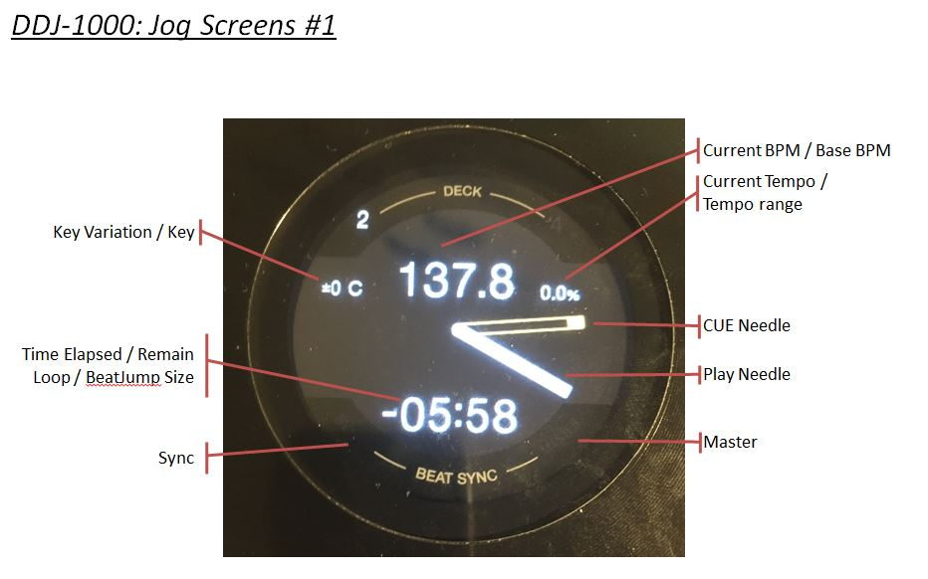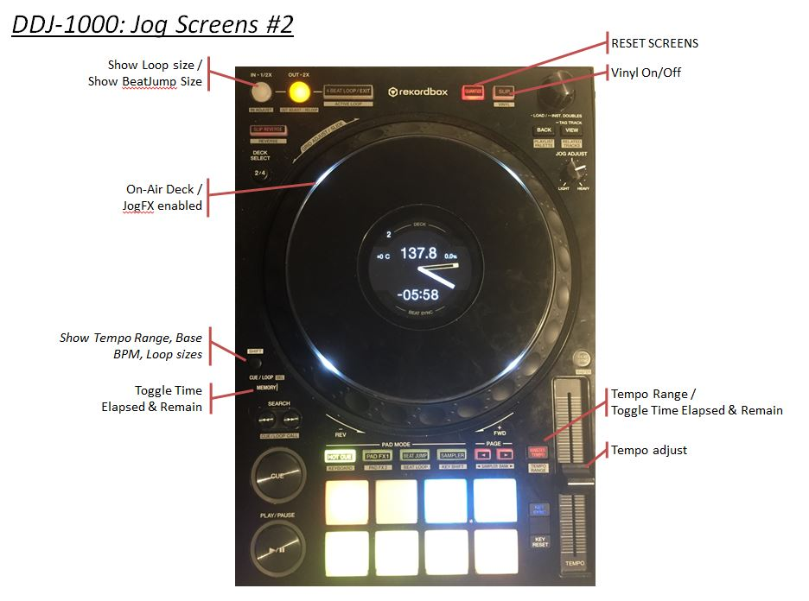

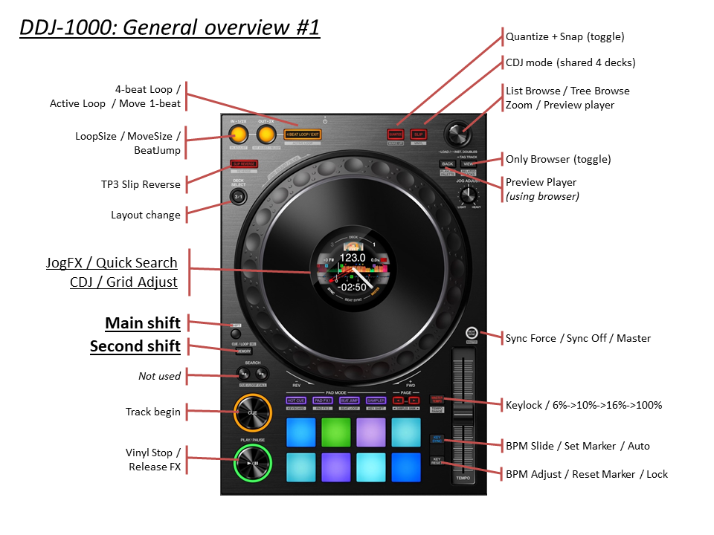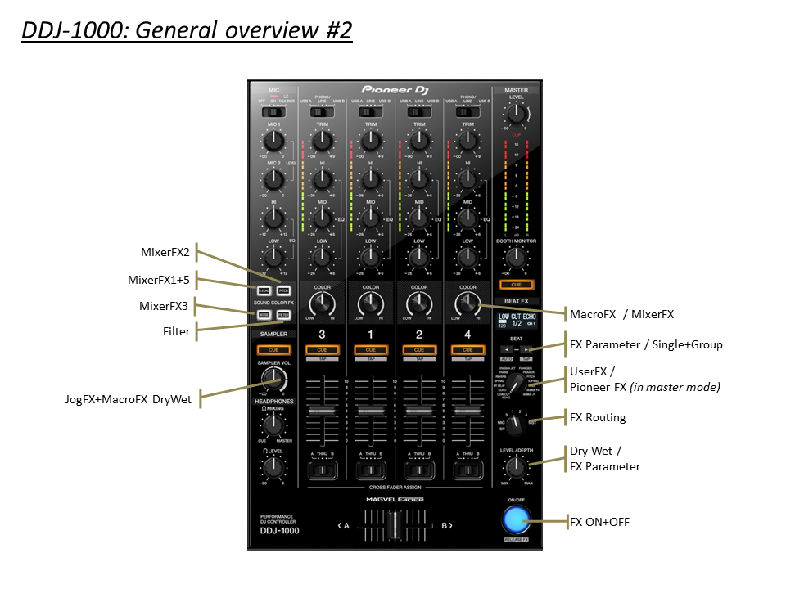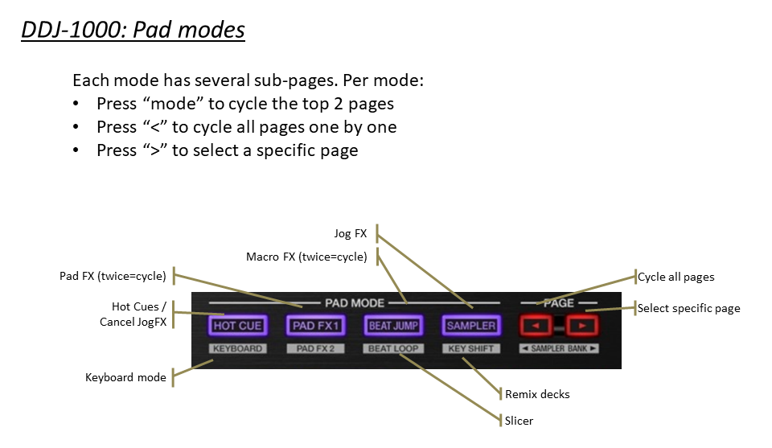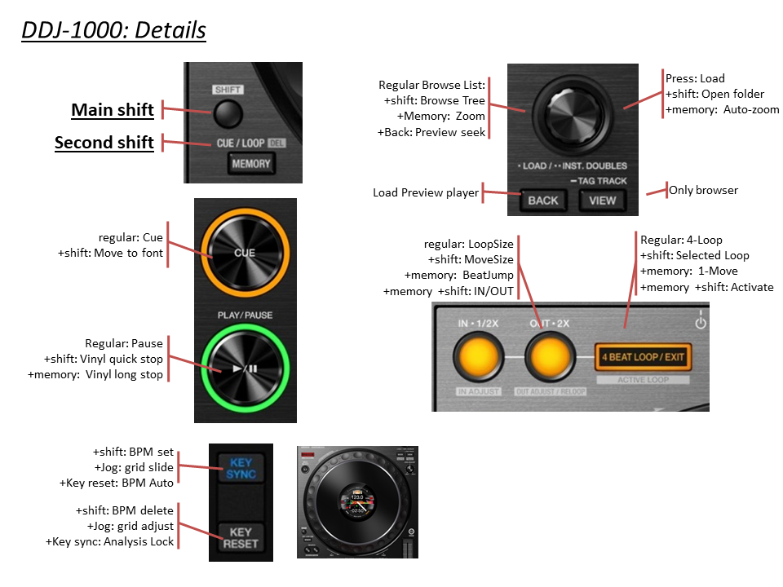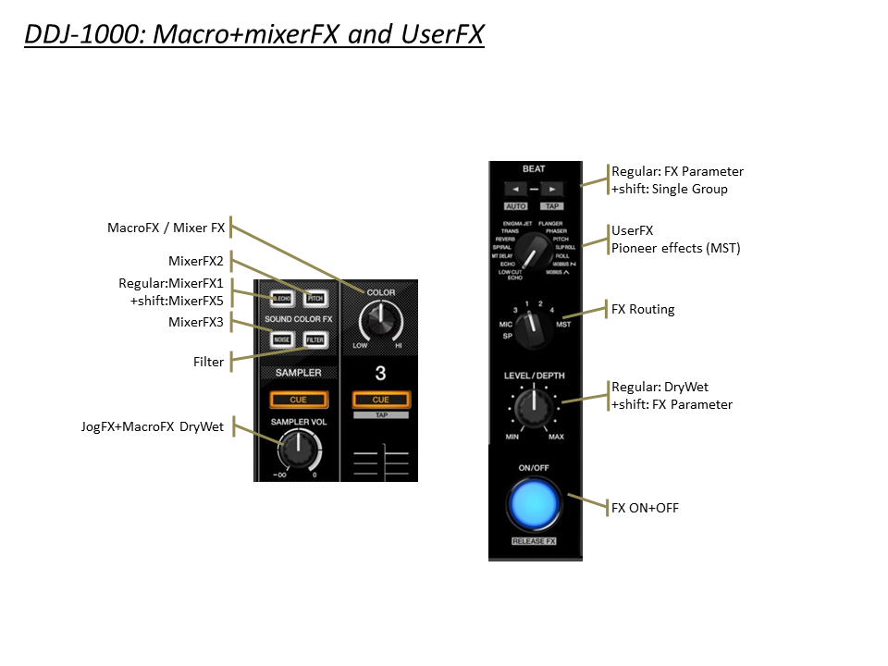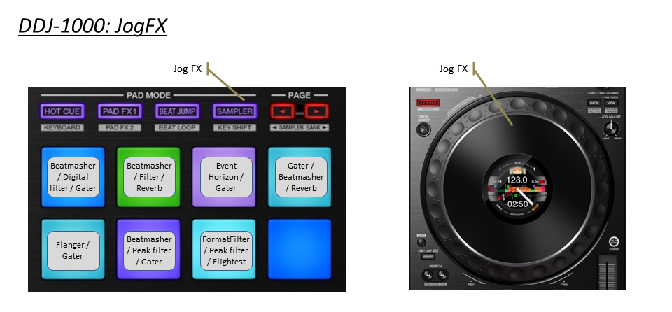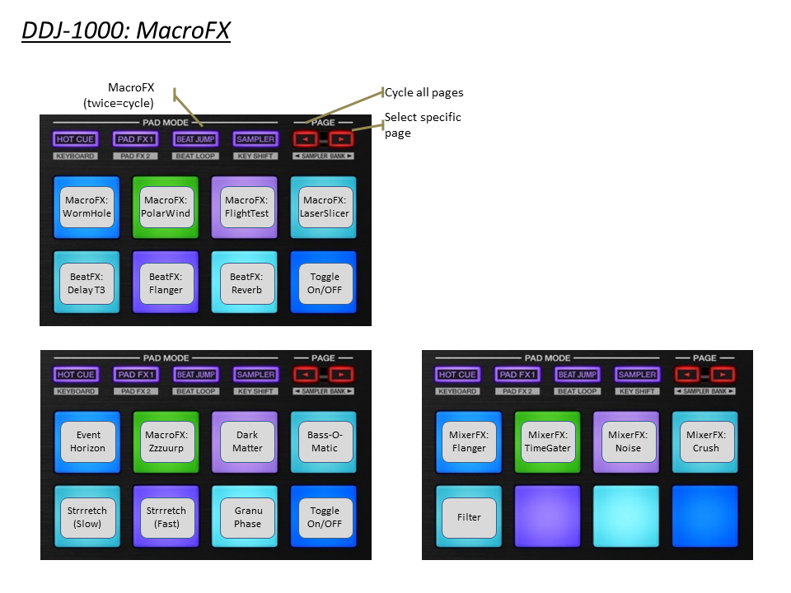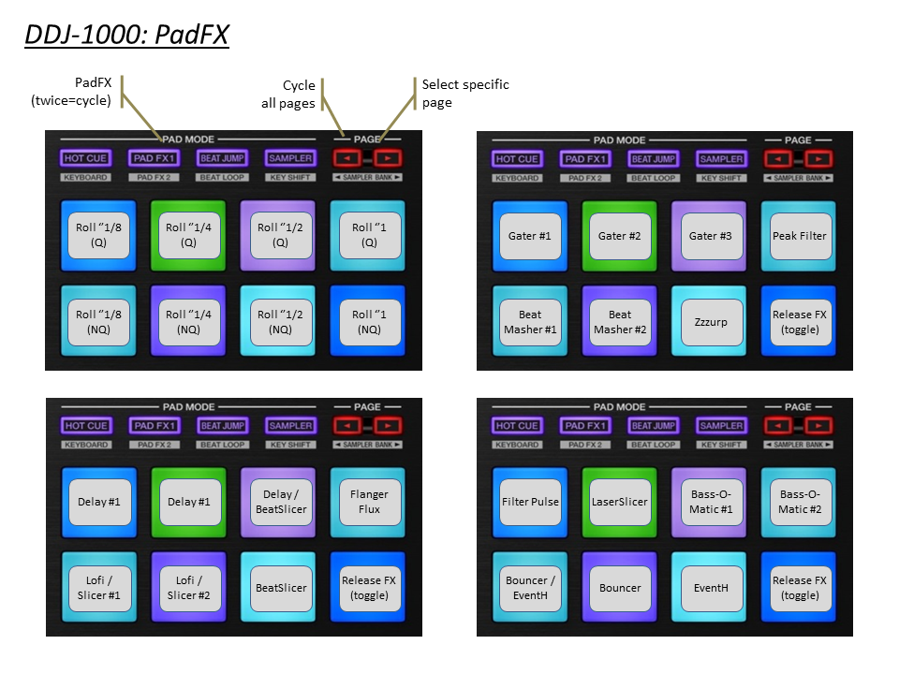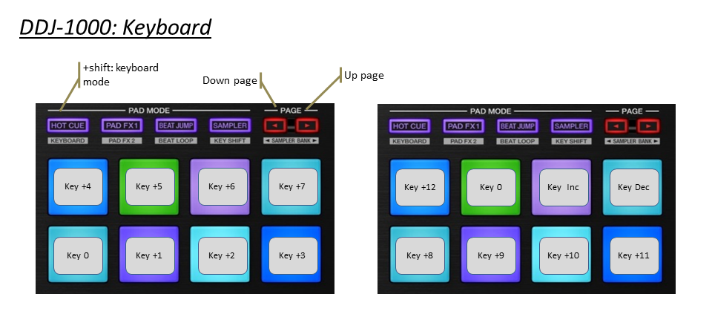

Complete reference:

|  |  |  |  |  |
| --- | --- | --- | --- | --- |
|  |  |  |  |  |
|  |  | Section JOG DISPLAYS |  |  |
|  | DDJ-1000 | Main Function | +Shift | +Memory Shift |
|  | BUTTON: LOOPS | Show Loop / Move size (for 2s) | *Move size* | *BeatJump* |
|  | BUTTON: MASTER TEMPO | *KeyLock Toggle* | *Tempo Range (6/10/16/100)* | Toggle Elapsed/Remain |
|  | BUTTON: QUANTIZE |  | RESET SCREENS |  |
|  | BUTTON: SLIP |  | Vinyl On/Off |  |
|  |  |  |  |  |
|  | DISPLAY: TIME | Time Elapsed / Remain | Loop Size / Move size |  |
|  | DISPLAY: BPM | Current BPM | Original BPM |  |
|  | DISPLAY: NEEDLE | Current Position |  |  |
|  | DISPLAY: PERCENTAGE | BPM Percentage | Tempo Range |  |
|  |  |  |  |  |
|  | DISPLAY: KEY VALUE | *Not Available yet* |  |  |
|  | DISPLAY: KEY VARIATION | Key Variation |  |  |
|  |  |  |  |  |
|  | JOG RING LED | On-Air Deck / JogFX enabled |  |  |
|  | DISPLAY: SYNC | Sync |  |  |
|  | DISPLAY: MASTER | Master |  |  |
|  |  |  |  |  |
|  |  |  |  |  |
|  |  |  |  |  |
|  |  | Section DECK |  |  |
|  | DDJ-1000 | Main Function | +Shift | +Memory Shift |
|  | SHIFT | Main Shift |  |  |
|  | MEMORY | 2nd Shift |  |  |
|  | KEY SYNC | *(see grid section)* | *(see grid section)* |  |
|  | KEY RESET | *(see grid section)* | *(see grid section)* |  |
|  |  |  |  |  |
|  | JOG (platter ) | Scratch / Pitch Bend | Quick Search |  |
|  | JOG (wheel side) | Pitch Bend |  |  |
|  |  |  |  |  |
|  | MASTER TEMPO | KeyLock Toggle | Tempo Range (6/10/16/100) | Time Elapsed / Remain |
|  | SLIP REVERSE | TP3 Reverse Flux | TP3 Reverse |  |
|  | DECK SELECT (1/2/3/4) | Select Deck 1-4 | Deck Flavor |  |
|  | SEARCH << >> |  |  |  |
|  |  |  |  |  |
|  | PLAY | Play/Pause | Vinyl Stop |  |
|  | CUE | Cue | Track Begin |  |
|  | BEAT SYNC | Sync Toggle | Sync Off | Set as tempo Master |
|  |  |  |  |  |
|  | QUANTIZE / WAKE UP | Quantize + Snap Toggle | Reset mapping |  |
|  | SLIP / VINYL | Flux Mode On/Off | Scratch On/Off |  |
|  | TEMPO | Tempo Control | Tempo Control (No sync) |  |
|  |  |  |  |  |
|  |  |  |  |  |
|  |  | Section BROWSER |  |  |
|  | DDJ-1000 | Main Function | +Shift | +Memory Shift |
|  | Turn Browser Knob | Scroll List | Scroll Tree | WaveForm Zoom Adjust |
|  | Push Browser Knob | Load Track | Open / close Folder | WaveForm Zoom Auto |
|  | BACK | Preview Player (Hold) | Scroll Favorites |  |
|  | VIEW | Browser Only (Toggle) | Goto Collection |  |
|  |  |  |  |  |
|  |  |  |  |  |
|  |  |  |  |  |
|  |  | Section BEATGRID |  |  |
|  | DDJ-1000 | + KEY SYNC | + KEY RESET | +Shift |
|  | KEY SYNC |  |  | Set Grid Marker |
|  | KEY RESET |  |  | Delete Grid Marker |
|  | KEY SYNC+RESET | Track ON/OFF LOCK | Auto Grid Marker |  |
|  |  |  |  |  |
|  | Turn Jog Wheel | Move Grid | BPM +/- |  |
|  | Turn BROWSER | Move Grid [ FINE ] | BPM +/- [ FINE ] |  |
|  | Push BROWSER | SLIDE AUTO | BPM AUTO |  |
|  |  |  |  |  |
|  |  |  |  |  |
|  |  | Section LOOP |  |  |
|  | DDJ-1000 | Main Function | +Shift | +Memory Shift |
|  | AUTO LOOP | 4-Beat loop | Loop (selected size) | Select Move 1-beat |
|  | 1/2X | Select Loop 1/2X | Select Move 1/2X | BeatJump / LoopMove |
|  | 2X | Select Loop 2X | Select Move 2X | BeatJump / LoopMove |
|  | IN | Loop IN | CaptureLoop (remix deck) |  |
|  | OUT | Loop OUT | DeleteLoop (remix deck) |  |
|  |  |  |  |  |

|  |  |  |  |
| --- | --- | --- | --- |
|  |  |  |  |
|  |  | Section MIXER |  |
|  | DDJ-1000 | Main Function | +Shift |
|  | MASTER LEVEL | Volume Master Out |  |
|  | MASTER CUE | MASTER CUE |  |
|  | BOOTH LEVEL | Volume Booth Out |  |
|  | TRIM | Gain |  |
|  | HI | Hi |  |
|  | MID | Mid |  |
|  | LOW | Low |  |
|  | CUE MONITORING | Monitoring | Echo Out Type (1/2/3/4) |
|  | CH FADER | Channel Fader | CH Fader Start |
|  | CROSSFADER | Crossfader |  |
|  | INPUT SELECT | Input select |  |
|  | CROSS F. CURVE | Crossfader Curve |  |
|  | USB A & B | USB A & B | Unload Deck |
|  |  |  |  |
|  |  |  |  |
|  |  |  |  |
|  |  |  |  |
|  |  | section BEAT FX |  |
|  | DDJ-1000 | Main Function | +Shift |
|  | BEAT < | Parameter #3 left |  |
|  | BEAT > | Parameter #3 Right |  |
|  | SELECT 1/2/3/4 | Select FX4 |  |
|  | Use MST for Pioneer FX |
|  | LEVEL/DEPTH | Dry/Wet FX4 | Vinyl Break (Release FX) |
|  |  |  |  |
|  | LOW CUT | Delay T3 |  |
|  | ECHO | Delay |  |
|  | MT DELAY | Ramp Delay |  |
|  | SPIRAL | Auto Bouncer |  |
|  | REVERB | Reverb T3 |  |
|  | TRANS | Gater |  |
|  | ENIGMA JET |  |  |
|  | FLANGER | Flanger |  |
|  | PHASER | Phaser |  |
|  | PITCH | Reverse Grain |  |
|  | SLIP ROLL | BeatSlicer |  |
|  | ROLL | BeatMasher 2 |  |
|  | MOBIUS SAW |  |  |
|  | MOBIUS TRI |  |  |
|  |  |  |  |
|  |  |  |  |
|  |  | section HOTCUE |  |
|  | DDJ-1000 | Main Function | +Shift |
|  | PAD 1 | Hotcue 1 | Delete Hotcue |
|  | PAD 2 | Hotcue 2 | Delete Hotcue |
|  | PAD 3 | Hotcue 3 | Delete Hotcue |
|  | PAD 4 | Hotcue 4 | Delete Hotcue |
|  | PAD 5 | Hotcue 5 | Delete Hotcue |
|  | PAD 6 | Hotcue 6 | Delete Hotcue |
|  | PAD 7 | Hotcue 7 | Delete Hotcue |
|  | PAD 8 | Hotcue 8 | Delete Hotcue |
|  | HOTCUE [Long Press] | Quantize |  |
|  | PARAMETER < |  | PITCH -0,01 |
|  | PARAMETER > |  | PITCH +0,01 |
|  |  |  |  |
|  |  |  |  |
|  |  |  |  |
|  |  | section BEATLOOP |  |
|  | = SLICER |
|  | DDJ-1000 | Main Function | +Shift |
|  | PAD 1 | Slicer #1 | 8 beats |
|  | PAD 2 | Slicer #2 | 16 beats odd |
|  | PAD 3 | Slicer #3 | 16 beats even |
|  | PAD 4 | Slicer #4 |  |
|  | PAD 5 | Slicer #5 |  |
|  | PAD 6 | Slicer #6 |  |
|  | PAD 7 | Slicer #7 |  |
|  | PAD 8 | Slicer #8 |  |
|  | PARAMETER < |  |  |
|  | PARAMETER > |  |  |
|  |  |  |  |
|  |  |  |  |
|  |  | section KEY SHIFT |  |
|  | = SAMPLER |
|  | DDJ-1000 | Main Function | +Shift |
|  | PAD 1 | Cell #1 / #9 | Column #1 Mute |
|  | PAD 2 | Cell #2 / #10 | Column #2 Mute |
|  | PAD 3 | Cell #3 / #11 | Column #3 Mute |
|  | PAD 4 | Cell #4 / #12 | Column #4 Mute |
|  | PAD 5 | Cell #5 / #13 | Column #1 Loop / 1-shot |
|  | PAD 6 | Cell #6 / #14 | Column #2 Loop / 1-shot |
|  | PAD 7 | Cell #7 / #15 | Column #3 Loop / 1-shot |
|  | PAD 8 | Cell #8 / #16 | Column #4 Loop / 1-shot |
|  | PARAMETER < | Pad 1 to 8 | Page - |
|  | PARAMETER > | Pad 9 to 16 | Page + |
|  |  |  |  |
|  |  |  |  |
|  |  | section KEYBOARD |  |
|  | DDJ-1000 | Main Function | +Shift |
|  | PAD 1 | Key +4 | Key +12 |
|  | PAD 2 | Key +5 | Key 0 |
|  | PAD 3 | Key +6 | Key Inc |
|  | PAD 4 | Key +7 | Key Dec |
|  | PAD 5 | Key 0 | Key +8 |
|  | PAD 6 | Key +1 | Key +9 |
|  | PAD 7 | Key +2 | Key +10 |
|  | PAD 8 | Key +3 | Key +11 |
|  |  |  |  |
|  | PARAMETER < | Next PFX page |  |
|  | PARAMETER > | Choose PFX pages |  |
|  |  |  |  |
|  |  |  |  |
|  |  |  |  |
|  |  | section SAVED LOOP |  |
|  | = PAD FX |
|  | DDJ-1000 | Main Function | +Shift |
|  | PAD 1 | Gater #1 | PAD FX page 1 |
|  | PAD 2 | Gater #2 | PAD FX page 2 |
|  | PAD 3 | Gater #3 | PAD FX page 3 |
|  | PAD 4 | Peak Filter | ROLL |
|  | PAD 5 | Beatmasher #1 |  |
|  | PAD 6 | Beatmasher #2 |  |
|  | PAD 7 | Zzzurp |  |
|  | PAD 8 | Release FX (toggle) |  |
|  |  |  |  |
|  | PAD 1 | Delay #1 | PAD FX page 1 |
|  | PAD 2 | Delay #2 | PAD FX page 2 |
|  | PAD 3 | Delay / BeatSlicer | PAD FX page 3 |
|  | PAD 4 | Flanger Flux | ROLL |
|  | PAD 5 | DigitalLofi / BeatSlicer #1 |  |
|  | PAD 6 | DigitalLofi / BeatSlicer #2 |  |
|  | PAD 7 | BeatSlicer |  |
|  | PAD 8 | Release FX (toggle) |  |
|  |  |  |  |
|  | PAD 1 | Filter Pulse | PAD FX page 1 |
|  | PAD 2 | LaserSlicer | PAD FX page 2 |
|  | PAD 3 | Bass-O-Matic #1 | PAD FX page 3 |
|  | PAD 4 | Bass-O-Matic #2 | ROLL |
|  | PAD 5 | Bouncer / EventHorizon |  |
|  | PAD 6 | Bouncer |  |
|  | PAD 7 | EventHorizon |  |
|  | PAD 8 | Release FX (toggle) |  |
|  |  |  |  |
|  | PAD 1 | Roll ‘’1/8 (quantize) | PAD FX page 1 |
|  | PAD 2 | Roll ‘’1/4 (quantize) | PAD FX page 2 |
|  | PAD 3 | Roll ‘’1/2 (quantize) | PAD FX page 3 |
|  | PAD 4 | Roll ‘’1 (quantize) | ROLL |
|  | PAD 5 | Roll ‘’1/8 (non-quantize) |  |
|  | PAD 6 | Roll ‘’1/4 (non-quantize) |  |
|  | PAD 7 | Roll ‘’1/2 (non-quantize) |  |
|  | PAD 8 | Roll ‘’1 (non-quantize) |  |
|  |  |  |  |
|  | PARAMETER < | Next PFX page |  |
|  | PARAMETER > | Choose PFX pages |  |
|  |  |  |  |
|  |  |  |  |
|  |  |  |  |
|  |  | section COLOR FX |  |
|  | = MIXER FX |
|  | DDJ-1000 | Main Function | +Shift |
|  | DUB ECHO | MixerFX: Flanger | MixerFX: Noise |
|  | PITCH | MixerFX: TimeGater |  |
|  | NOISE | MixerFX: Crush |  |
|  | FILTER | Filter |  |
|  |  |  |  |
|  | FILTER (KNOB) | Macro FX / Mixer FX |  |
|  | SAMPLER VOLUME | Macro FX Wet |  |
|  |  |  |  |
|  |  |  |  |
|  |  |  |  |
|  |  | section BEAT JUMP |  |
|  | = MACRO FX / MIXER FX |
|  | DDJ-1000 | Main Function | +Shift |
|  | PAD 1 | MacroFX: WormWhole | MACRO FX page 1 |
|  | PAD 2 | MacroFX: PolarWind | MIXER FX |
|  | PAD 3 | MacroFX: FlightTest | MACRO FX page 2 |
|  | PAD 4 | MacroFX: LaserSlicer |  |
|  | PAD 5 | BeatFX: Delay T3 |  |
|  | PAD 6 | BeatFX: Flanger |  |
|  | PAD 7 | BeatFX: Reverb |  |
|  | PAD 8 | Toggle On/OFF |  |
|  |  |  |  |
|  | PAD 1 | MixerFX: Flanger | MACRO FX page 1 |
|  | PAD 2 | MixerFX: TimeGater | MIXER FX |
|  | PAD 3 | MixerFX: Noise | MACRO FX page 2 |
|  | PAD 4 | MixerFX: Crush |  |
|  | PAD 5 | Filter |  |
|  | PAD 6 |  |  |
|  | PAD 7 |  |  |
|  | PAD 8 | Toggle On/OFF |  |
|  |  |  |  |
|  | PAD 1 | MacroFX: EventHorizon | MACRO FX page 1 |
|  | PAD 2 | MacroFX: Zzzuurp | MIXER FX |
|  | PAD 3 | MacroFX: DarkMatter | MACRO FX page 2 |
|  | PAD 4 | MacroFX: Bass-O-Matic |  |
|  | PAD 5 | MacroFX: Strrretch (Slow) |  |
|  | PAD 6 | MacroFX: Strrretch (Fast) |  |
|  | PAD 7 | MacroFX: GranuPhase |  |
|  | PAD 8 | Toggle On/OFF |  |
|  | PARAMETER < | Next MFX page |  |
|  | PARAMETER > | Choose MFX pages |  |
|  |  |  |  |
|  |  |  |  |
|  |  |  |  |
|  |  | section SLICER LOOP |  |
|  | = JOG FX |
|  | DDJ-1000 | Main Function | +Shift |
|  | PAD 1 | Beatmasher / Digital filter / Gater |  |
|  | PAD 2 | Beatmasher / Filter / Reverb |  |
|  | PAD 3 | Eventhorizon / Gater |  |
|  | PAD 4 | Gater / Beatmasher / Reverb |  |
|  | PAD 5 | Flanger / Gater |  |
|  | PAD 6 | Beatmasher / Peak filter / Gater |  |
|  | PAD 7 | FormatFilter / Peak filter / Flightest |  |
|  | PAD 8 | Release FX (toggle) |  |
|  | PARAMETER < |  |  |
|  | PARAMETER > |  |  |
|  |  |  |  |